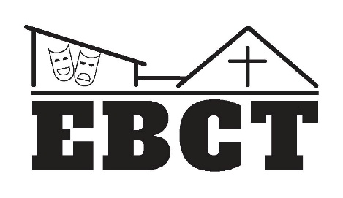
EAST BRAINERD COMMUNITY THEATER
AUDITION FAQ’s

Where are auditions held? Auditions are held at Christ United Methodist Church on the corner of East Brainerd Road and Morris Hill Road, 8645 East Brainerd Road, Chattanooga TN 37421.
Where do I park? Free parking is available at the church.
Which door do I enter? Enter through the main doorway under the covered pull-through on the Morris Hill Road side of the church. Look for our EBCT Sandwich Board Sign.
Where do I go once I’m inside? Look for EBCT Directional Signs and an EBCT Greeter who will help you find the audition space. Most of the time, auditions are held in the main sanctuary.
What time are auditions? Should I come early? Auditions usually begin promptly at 7:00 PM. If you have not completed the audition form found on our website in advance, please arrive 10-15 minutes early to do this before the auditions begin. Audition forms can be downloaded and printed from our website, or you can get a blank one at auditions.
What should I wear to auditions? Please wear comfortable clothes that you can move around in and close-toed shoes (not slip-ons) that are safe on the stage floor. If you are auditioning for a musical, there will be a dance sequence, so please where clothes that you can dance in!
What do I need to prepare for the audition? You do not need to prepare anything! However, it never hurts to be familiar with the show in advance. Auditions usually consist of a song you are taught at the audition, a simple dance sequence taught at the audition, and cold readings from the script. If callbacks are required, the director may ask actors who are called back to prepare specific material for the callback audition. If so, you will receive these instructions when you are called back.
How long will the audition last? Audition times will vary depending on the type of show (play or musical) and what the director wants to see. Usually play auditions include cold readings of scenes from the play, and you may be asked to read more than once. Musical auditions include singing, dancing and cold readings. Please plan to stay at least an hour. Musical auditions may require up to two hours depending on the number of auditionees.
How will I know the results of the audition? You will be asked for contact information on the audition form. The director or producer will contact you when the cast is decided by either text or email. You will receive specific instructions at the audition for how to receive audition results. All auditionees will be notified of the casting results. If cast, you will be asked to accept your role by replying to the notification. Once all roles have been cast, the cast list is shared on our website and via social media.
More questions? Send us a message through our website at www.ebctchatt.com or through our Facebook page! We look forward to seeing you soon at auditions!!!

